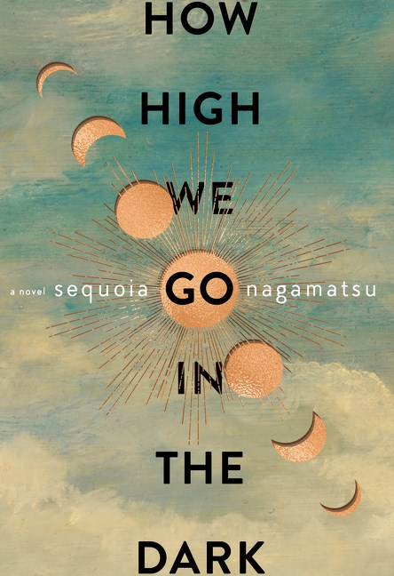

For more information, please contact Isabelle Oliveira at isabelleoliveira@hotmail.com
How High We Go in the Dark
Sequoia Nagamatsu
Publication date: 18th January 2022
Hardback £16.99

Climate Crisis? Pandemic? What could life be like for the survivors of the apocalypse we are ushering in?

“I’ve never been a great reader of speculative fiction, but this visionary, wildly imaginative début novel has made me realise what I’m missing.”
– Caroline Sanders, The Bookseller

Dr. Cliff Miyashiro arrives in the Arctic Circle to continue his recently deceased daughter’s research, only to discover a virus, newly unearthed from melting permafrost. The plague unleashed reshapes life on earth for generations. Yet even while struggling to counter this destructive force, humanity stubbornly persists in myriad moving and ever inventive ways.
Among those adjusting to this new normal are an aspiring comedian, employed by a theme park designed for terminally ill children, who falls in love with a mother trying desperately to keep her son alive; a scientist who, having failed to save his own son from the plague, gets a second chance at fatherhood when one of his test subjects – a pig-develops human speech; a man who, after recovering from his own coma, plans a block party for his neighbours who have also woken up to find that they alone have survived their families; and a widowed painter and her teenaged granddaughter who must set off on cosmic quest to locate a new home planet.
From funerary skyscrapers to hotels for the dead, How High We Go in the Dark follows a cast of intricately linked characters spanning hundreds of years as humanity endeavours to restore the delicate balance of the world. This is a story of unshakable hope that crosses literary lines to give us a world rebuilding itself through an endless capacity for love, resilience, and reinvention.

“Haunting and luminous, How High We Go in the Dark orchestrates its multitude of memorable voices into beautiful and lucid science fiction. An astonishing debut.”
– Alan Moore, creator of Watchmen and V for Vendetta

