Marketing Report
How window displays in bookstores prompt the impulsive purchase of a new release.
Introduction
There are many factors influencing the purchase of a book and some decisions can be made before the customer even enters a bookshop. Whether they are looking for a specific book or simply browsing, bookstores need to be able to take advantage of the customer’s curiosity. Window displays in stores are a common tactic in all areas of marketing to draw in customers. As the number of new book titles each year increases dramatically, publishers and booksellers must find new and creative ways to make sales (Thompson, 2013). In John B. Thompson’s Merchants of Culture, it is reported that a publisher remarks that ‘It’s become easier to publish and harder to sell – that’s the paradox. Any old sod can publish a book now, but actually getting it out to the public has become much trickier’ (Thompson, 2013).
Literature Review
Compelling window displays can make a huge difference in store foot-traffic and consequently sales. For example, a study carried out in 2000 found that store environment makes a significant difference in customers’ buying habits and impulses (Kumar & Karande, 2000), and a window display can contribute hugely to a customer’s perception of the retailer (Cohen, 2001). With the overwhelming number of options, it is increasingly important to create a cohesive window display that resonates with the desires of the customer. A. Edgar and P. Sedgwick write, ‘More recent approaches to consumption recognize the utopian element inherent in shopping. An ideology of shopping may be analyzed, where shopping or consumption are perceived as solutions to the discontents of one’s life’ (Edgar & Sedgwick, 2003; Abdin & Aziz, 2012).
Creating an effective window design – one that not only catches the customer’s eye but compells them to come inside – requires a variety of design elements which describe the selling point (Cohen, 2001). The customer needs to get an intuitive sense that the product, service, or idea will better their lives while simultaniously having enough information to make them decide to enquire further in the first three seconds (The Retail Doctor, 2010).
Further on from the front of the store, research shows that the layout of the store can influence what a customer buys. For example, in the case of bookselling, keeping a clear front entrance will help make the customer feel comfortable upon entry and placing books on the right wall of the entrance will help them sell (Heil, 2019).
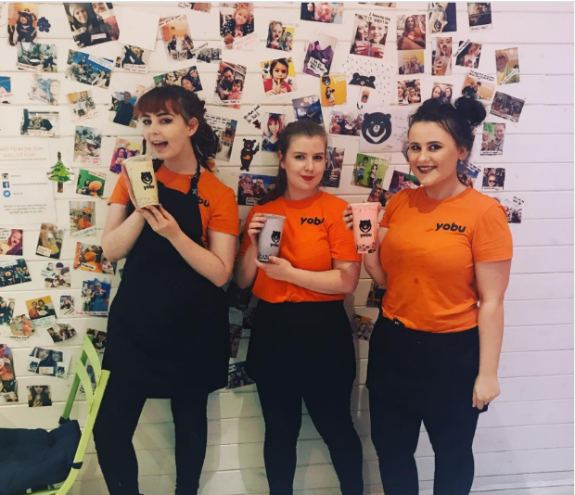
Case Studies
Figure SEQ Figure \* ARABIC 1 Image on @yobuuk Instagram page.
Bubble Tea: Tealith and Yobu (two prominent bubble tea cafés) have found a way to make coming into the store more of a positive customer experience. What is unique about these companies is that despite having a product that customers want, they also make buying their product an experience.
Yobu has a wall of polaroid pictures where customers can take photos and stick them on the wall (Figure 1).
Tealith uses full customer loyalty cards to decorate one of their walls, encouraging customers to fill their cards so that they can get a photo with their loyalty card on the wall (Figure 2).
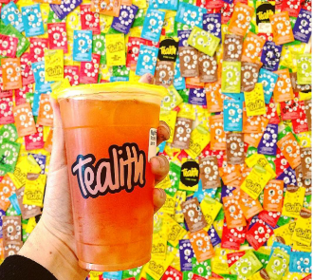
These are key examples of customer interaction because they combine physical instore displays and social media. Consumers can not only interact with them online but also feel like they are a part of a community instore. This helps to create an association between the company and a fun experience thus driving up sales.
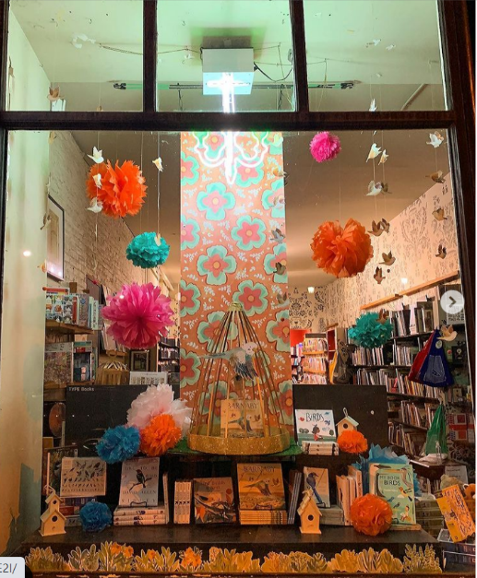
‘Customers Enliven Bookstore Display’: Canterbury bookstore in Wisconsin sent out emails to their mailing list in 2000 asking for customers to come sit in the window to read. Encouraged to bring pyjamas and blankets, 127 customers responded and came to sit in the window. People interacted with the models as they walked by which made the bookstore stand out in the high-street filled with holiday displays. The owner, Trudy Barash, said she noticed a huge increase in foot traffic and made it an annual tradition (Wells, 2000).
Figure SEQ Figure \* ARABIC 2 Image from @tealith_bubbletea Instagram page.
Type Books: An article in a 2015 edition of Publisher’s Weekly featured Toronto’s Type Books for their unique approach to window displays. Taking inspiration from events in the literary world, new releases, or national holidays, one employee, Kalpna Patel, creates a new elaborate display every six weeks out of paper and fabric. According to Type’s community manager, they always see an increase in sales when customers share their displays on social media (Godfrey, 2015).
Figure Image depicting window dispay based on 'Barnaby' @typebooks Instagram page.
Booksellers
One problem that publishers would face when sending out materials for book promotion is convincing booksellers to use/ build the display. This can be overcome by pitching that the display will bring people into the store and thus prompt more sales of their other stock. Fredi Verdesca, owner of Jami’s and JCC, two clothing chains based in Florida, observes that ‘Many customers come in, based on what they see in the window. They may not necessarily buy that, but they see more options once they're inside.’ (Cohen, 2001). Also, interesting book displays may lead to promotion of both the book and the bookstore on social media or other channels of mainstream media (newspaper, television, etc.). While telling the story of how a life-size mannequin of Captain Haddock caused mixed reactions with customers and passers-by, Martin Latham, manager of Waterstones Canterbury, said ‘This level of public engagement surely bodes well for bookshops' survival. Passers-by are stopping, and bothering’ (Latham, 2012). This could also be a way to actively involve bookstores in the release of a a
Display concepts
When thinking of displays, there are various elements that need to be considered in order to create a cost-effective and attractive display. Depending on genre, audience, and book cover, potential customers will be attracted to or expect certain things. For example, a person interested in mysteries and thrillers may be intrigued by a black display whereas a customer looking for romance may like a more delicate display with flora and fauna. Using the information available about the book and its audience, these questions can be applied (The Retail Doctor, 2010):
- Genre:
  - what colour/pattern would be cohesive with the book cover?
  - Can I make the display eye catching without overwhelming the customer?
  - What is it about this genre that sells and how can I replicate that emotion?
- Interactivity
  - Is there an element of this book I can use to make the display interactive?
  - What would the intended audience be excited to see?
  - If there is no interactivity, can I increase engagement through some other means? For example, make the aesthetics social media ready, or include hashtags.
- Booksellers
  - Would the bookseller be excited to be a part of this campaign?
  - How can I make it more likely for them to participate?
  - Can most bookstores, independent of size, take part?
  - Is there any other release/display that I would competing with for window space?
Conclusion
Window displays capture the attention of both returning and potential customers and thus is a great way to put a book at the forefront of the public’s mind. In conjunction with social media, it can be a useful tool to increase sales of a new release as well as other titles by increasing engagement with the bookstore. Though cost to produce such displays can be an issue, the research suggests that the increase in sales make it a worthwhile investment. Other methods of marketing, though effective, rely on the customer to keep a prolonged interest whereas window displays greatly increase the chance impulse buys. This effect can be taken further by creating a way for the customer to engage with the display – either with a social media campaign or interactive element. While this cannot be an option for every release, it should certainly be considered when discussing marketing strategies.
‘If your book is not in the front of the bookstore, displayed cover up or cover out, but merely stocked spine out in a specialist section somewhere in the store, you’ll lose that impulse purchase.’ (Thompson, 2013)

Bibliography
Abdin, N. A. Z. Z. & Aziz, A. A., 2012. 'Window Display Compositions: Its Influences on Youths in Malaysia',. Procedia - Social and Behavioral Sciences, Issue 38, pp. 355-361.
Cohen, D., 2001. WINDOW SHOPPING; IN AN EFFORT TO LURE SHOPPERS ONTO THEIR SALES FLOORS, RETAILERS ARE CONSTANTLY SEEKING WAYS TO SPRUCE UP THEIR WINDOW DISPLAYS. WWD, 4 October, p. 64.
Edgar, A. & Sedgwick, P., 2003. Cultural Theory: The Key Concepts. London: Routledge .
Godfrey, L., 2015. Type Books Turns Window Displays into Art. Publisher's Weekly, 15 June, p. 15.
Heil, K., 2019. How the Psychology of Store Layout Impacts Customers. [Online]
Available at: https://www.palmerretailsolutions.com/blog/psychology-of-store-layout-impacts-customers
[Accessed 01 December 2021].
Kumar, V. & Karande, K., 2000. The Effect of Retail Store Environment on Retail Perfomance. Journal of Business Research, Issue 49, pp. 167-181.
Latham, M., 2012. It Started with a Kiss. The Bookseller, 4 February, p. 13.
The Retail Doctor, 2010. Building Powerful Window Displays. Tech Trader, April, pp. 55-57.
Thompson, J. B., 2013. Merchants of Culture: The Publishing Business in the Twenty-First Century. Oxford: Polity Press.
Wells, S., 2000. Customers Enliven Window Display. Publishers Weekly, 14 February, p. 89.

